**40375 Assignment: HTML/Javascript Fundamentals**

For Learner Use:

|  |  |
| --- | --- |
| Name of Learner |  |
| Learner ID |  |
| Student Number |  |
| Date of Project Given |  |
| Project Due Date |  |
| Location / Branch | iStudent Academy, Durban |

For Assessor Use:

|  |  |  |
| --- | --- | --- |
| **Assessment Number** | **1st X** | **2nd X** |

|  |  |  |  |  |  |
| --- | --- | --- | --- | --- | --- |
| **Quality of Documentation**  **40%** | **Timely completion**  **15%** | **Level of Content**  **25%** | **Query Handling**  **20%** | **Total**  **100%** | **Competency**  **Status** |
|  |  |  |  |  |  |

|  |  |  |
| --- | --- | --- |
| **Comments** | | **Date** |
| **Assessor** |  |  |
|  |
|  |
|  |
| **Moderator** |  |  |
|  |
|  |

|  |  |  |  |
| --- | --- | --- | --- |
| Candidates Signature |  | Date of Submission |  |
| Assessors Signature |  | Date Marked |  |

1. HTML Website [20]

You are required to design a login page below. The website needs to include the following minimum requirements. Form functionality must be done using JavaScript.

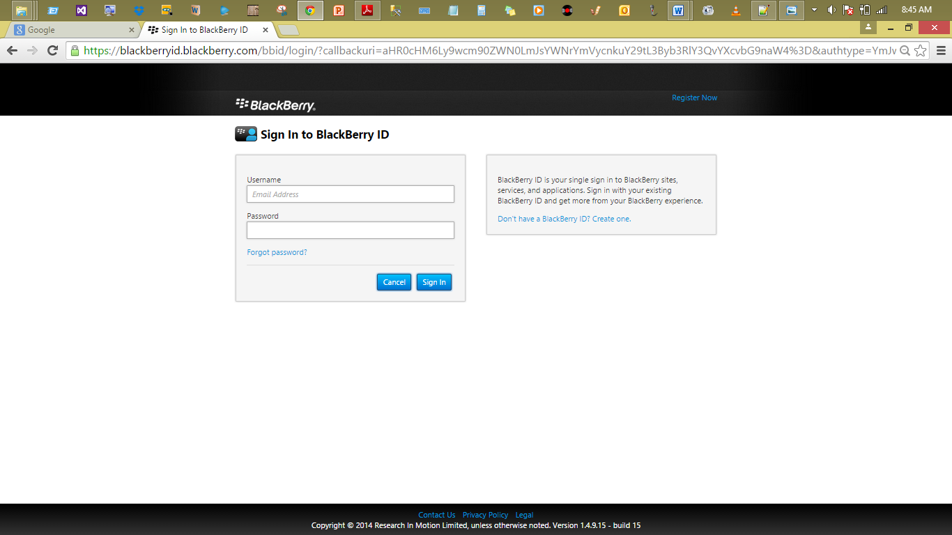

* A user must enter a username and password;
* Ensure that a user enters a valid email address.
* Password characters should be hidden.
* When a sign in button is clicked, username should be displayed on the alert window.

|  |  |
| --- | --- |
| **Description** | **Mark Allocation** |
| Form layout & design | 5 |
| Tables/Divs | 2 |
| Links | 1 |
| Sign in button & alert window | 2 |
| Images | 2 |
| CSS (CSS to control page styling. Can be internal or external) | 3 |
| Valid email | 3 |
| Password | 1 |
| Register now link | 1 |
| **Total** | **20** |

1. Register now link should display the following page below: use the screenshots to assist you with requirements.



* A user must enter all required details;
* Ensure that a user enters a valid email address.
* ID number should only accept 13 digits.
* Password characters should be hidden.
* Make sure that password inputs match.
* Facebook link should take you to Facebook page, same goes with Twitter.
* When a register button is clicked, all details should be displayed on another blank page.

**Note:**

Details will be displayed only if password input matches, if they do not match, an informative message to the user should be displayed on screen

|  |  |
| --- | --- |
| **Description** | **Mark Allocation** |
| Form layout & design | 9 |
| Tables/Divs | 2 |
| Links | 2 |
| Horizontal line | 1 |
| Images | 2 |
| CSS (CSS to control page styling. Can be internal or external) | 5 |
| Valid email | 3 |
| ID number | 3 |
| Password | 1 |
| Password match | 3 |
| Facebook/Twitter | 2 |
| Fonts & headings | 2 |
| Javascript and functions | 2 |
| **Total** | **37** |

1. You are creating a shape using canvas. Which JavaScript method do you use to create the shape? (The method name would replace the word METHOD in the following code.) [1]

<script>

function f1() {

var canvas =

document.METHOD("smlRectangle");

context = canvas.getContext("2d");

context.fillStyle = "rgb(0,0,255)";

context.fillRect(10, 20, 200, 100);

}

</script>

a) context.strokeStyle

b) getElementById

c) getIdByElement

d) getCanvas

1. Which of the following elements is not considered to be semantic markup? [1]

a) article

b) section

c) div

d) aside

5. You are blogging on your Web site and want part of the information to be available for other Web sites to use and display. Which HTML5 element should you use to set off the content to be syndicated? [1]

a) summary

b) details

c) article

d) div

6. How many rows does the following table have? [1]

<table>

<tr>

<th>Item</th>

<th>Price</th>

</tr>

<tr>

<td>Popcorn</td>

<td>$4</td>

</tr>

<tr>

<td>Candy</td>

<td>$3</td>

</tr>

<tr>

<td>Soda</td>

<td>$3</td>

</tr>

<tr>

<td>Soda</td>

<td>$3</td>

</tr>

</table>

Answer:

|  |
| --- |
|  |

1. You are developing a customer web form that includes the following HTML input field. [1]

<input id=”txtValue”/>

If a customer enters a value in the input field, then it must be a numeric value. You need to add validation to the input field. Which HTML should you use?

A. <input id=”txtValue” type-”text” pattern=”/#” />

B. input id=”txtValue” type=”integer” />

C. <input id=”txtValue” type=”number” /><

D. <input id=”txtValue” type=”text” required=”required”/>

Complete the following sentences by writing the correct word or words in the blanks provided. **[13]**

1. An HTML tag that doesn’t require an end tag is called a(n) ________ tag.
2. A(n) __________ __ works with an element to describe data in enough detail for rendering.
3. The __________ __ is a declaration that is found at the very top of almost every Web page.
4. A __________ __ element or attribute has been removed from the list of available HTML elements according to the W3C.
5. A __________ __ image is made up of pixels, whereas a __________ __ image is made up of lines and curves based on mathematical expressions.
6. New to HTML5, the __________ __ element specifies the type of figure you’re adding, such as an image, diagram, photo, and so on.
7. The __________ __ element adds a caption to an image on a Web page, and you can display the caption before or after the image.
8. Using the __________ __ element, the Web page becomes a drawing pad, and you use JavaScript commands to draw pixel-based shapes on a canvas that include color, gradients, and pattern fills.
9. . __________ __ is a language for describing 2D graphics in Extensible Markup Language (XML).
10. The HTML5 __________ __ element and __________ __ element enable you to provide multimedia from a Web browser without the need for plug-ins.
11. A _________ is a recipe we direct the computer to execute to result in a particular display or action.
12. JavaScript __________ are the names of variables and functions.
13. You notice that a part of your JavaScript program represents a sequence of actions that is logically separate from other parts of program. It likely will be useful to define a ____________________ to perform that specific sequence.